**Blazor-Exercise 1**

# **admin login, jobs list, users list**

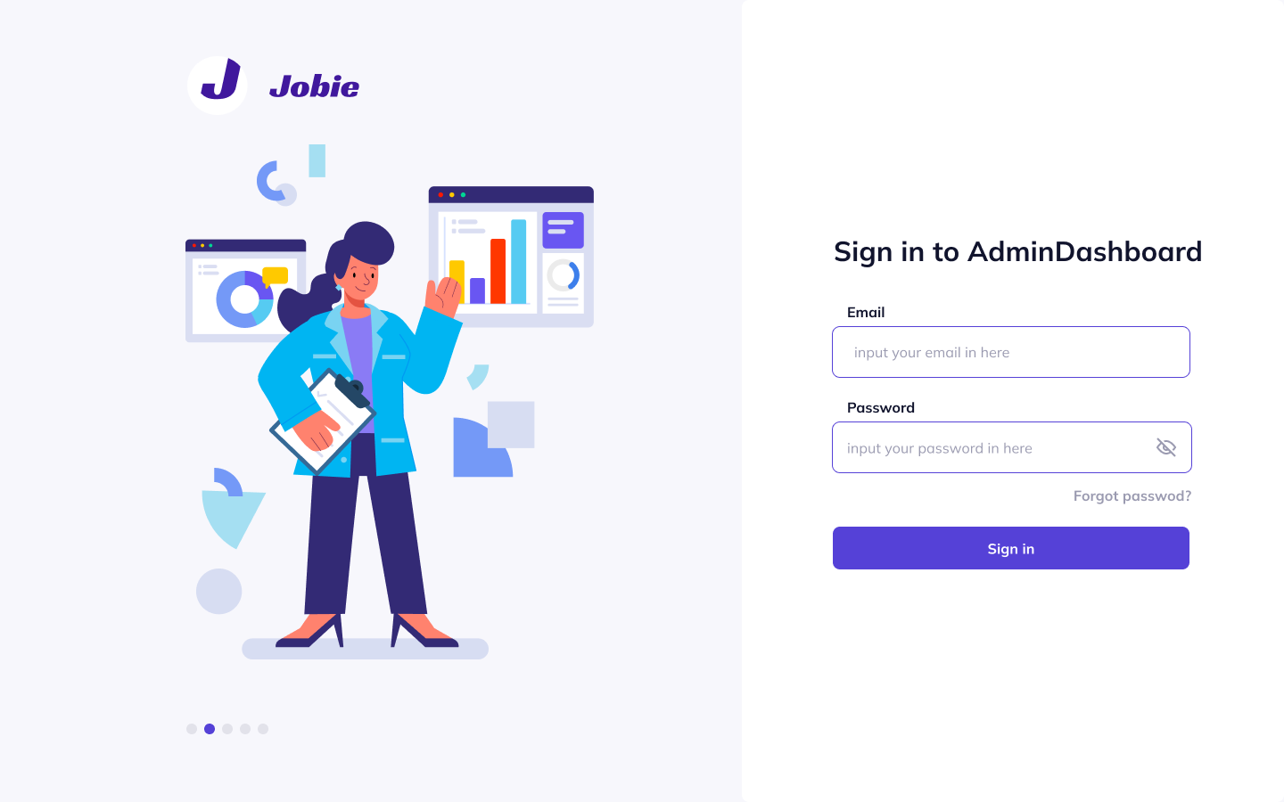

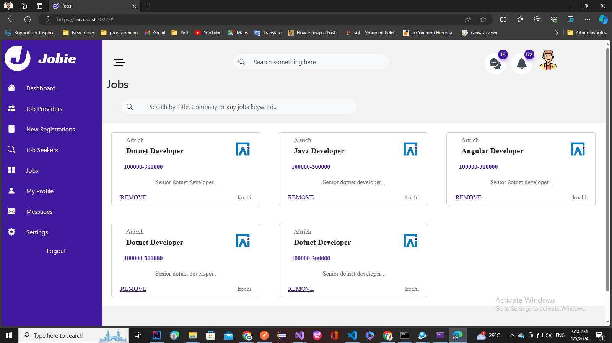

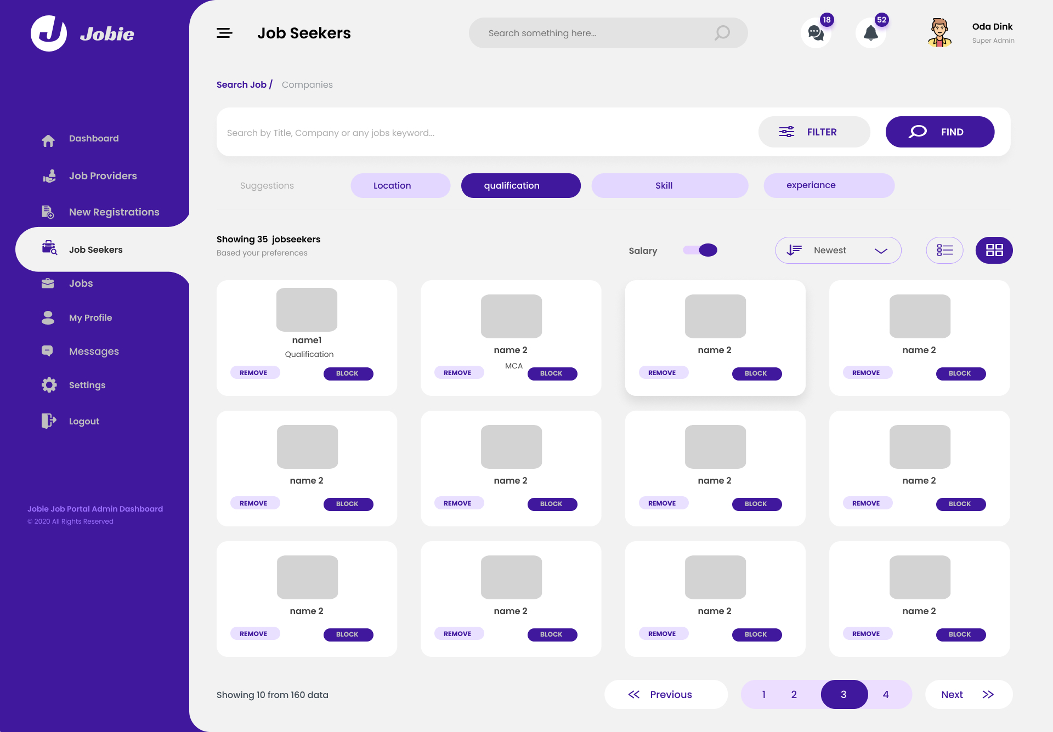

* Design and Implement a login page for admin
* Design and Implement users list as shown above.
* Design and Implement Jobs list page
  + Implement search feature
  + Implement remove feature